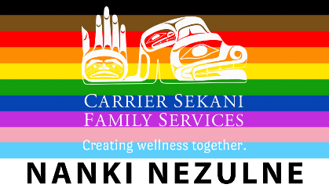 | CSFS Nanki Nezulne  (Our Two Spirits): Adult (18+) LGBTQ2+ Health and Wellness Services Referral Form

Referral Form: For Individual Services

Individual Seeking Support
Full Name: |  |  |  | Date of Birth:
 | Last | First | M.I.

Address:
 | Street Address | Apartment/Unit #

 | City | Province | Postal Code

Phone: |  | Email

Primary First Nation/Band: |  | Home Community:

Referral

Is client the client aware that this referral is being made? Yes No

Reason for this referral:

Referral Comes From
Name: |  | Title:
Agency: |  | Date:
Phone Number:
Email:
Signature: |  |  | Date:

Program Contacts
Hunter Brazzoni: Special Projects-Resource and Inclusion (Program Coordinator)
Phone: 250-251-6781 Email: hbrazzoni@csfs.org

Brittany Clark-Wakefield: LGBTQ2+ Counsellor
Phone: 778-349-1448 Email: bcwakefield@csfs.org

Please Note: Clients can also access this program directly by calling one of the people listed above.

